**Distributed Systems**

**Lab Exam**

Naga Tharun Makkena

SE20UCSE105

Problem 1: **Develop a client-server application that operates concurrently during daytime."**

Output:

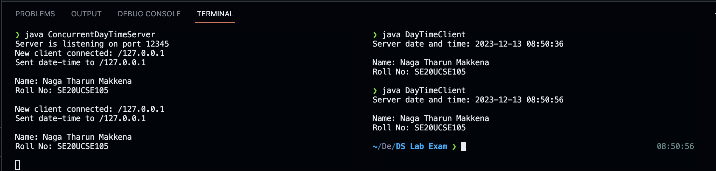

Code:

